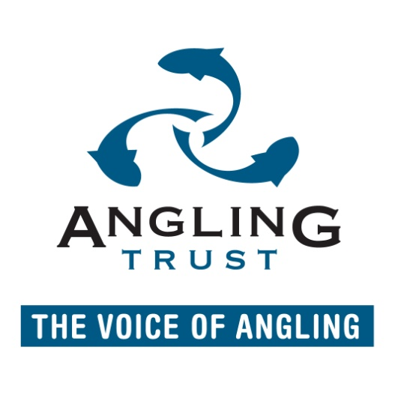

Joint statement about Otters and Fisheries from Angling Trust, English Nature and the Environment Agency

The Wildlife Management Group met recently to exchange information and to seek opportunities to resolve issues regarding otters and freshwater fisheries. The meeting was attended by experts from the Angling Trust, Natural England, the Environment Agency, the Angling Trades Association and others. It focussed, in particular, on the problems involving predation on specimen-sized coarse fish in rivers, although a wide range of issues were also debated. The continuing issue of fencing for selected stillwaters was also discussed in depth
The Group identified the areas of common ground, and it has started to explore how it can help anglers and the Environment Agency develop healthy and balanced river environments and habitats capable of supporting sustainable, diverse fish populations. Work is progressing on establishing the current distribution of otters, listing useful reference documents and producing guidance to fishery managers on creating sustainable habitats for fish and other forms of wildlife.
During the meeting it became clear that there are several, widely-quoted misconceptions about otters which need to be addressed and corrected:-
• ‘The otter predation problem has arisen because of the reintroduction programme’. Otter numbers have increased naturally throughout Britain as a consequence of successful recolonisation and breeding following a major decline in numbers caused by pesticides. The reintroduction programme has simply increased the speed of recovery in parts of England, notably in East Anglia.
• ‘The reintroduction programme is continuing unchecked’. Between 1983 and 1999 a small number (117) of captive-bred otters were released to the wild by the Otter Trust. The Vincent Wildlife Trust released rehabilitated animals between 1990 and 1996 (49), over half as part of a Yorkshire release programme, but also a few into East Anglia, Northumbria and on the Trent. No introductions of captive-bred otters have occurred since 1999. There have been releases of rehabilitated or orphaned animals, once they have been nursed back to health, which number no more than four or five a year. As far as it is practicable, rehabilitated otters are released back to the areas where they were found.
• ‘Trapping or culling is needed to control otter numbers’. There is no call or case for the culling or trapping of otters, which enjoy full protection under international and national legislation. Otter numbers will be constrained by available breeding habitat and prey.
• ‘Otters are eating coarse fish because of the decline in eel populations’. Otters are opportunist predators which tend to catch and consume fish most readily available to them. There is no evidence that they ‘prefer’ or select particular fish species.
It was agreed that the over-arching strategy should be to create and maintain healthy aquatic environments where balanced populations of fish and otters can co-exist in a sustainable manner. The majority of complaints about otter predation on rivers have arisen where fisheries are suffering from one or more environmental problems - over-abstraction, pollution, habitat damage, etc. The Group recognised that there are and would continue to be site-specific problems involving levels of predation which may reduce the amenity and fishery value.
The Group is exploring areas of possible applied research which might be usefully undertaken to enhance knowledge of otters in the wild and their impacts on fisheries with unbalanced fish populations. It would appear that problems are localised to certain rivers, rather than being universal, and it is important to understand why this is the case. Part of that process will be to identify fish populations which are considered to have been adversely affected by otter predation to assess the nature and severity of the problems and to cross-reference this information to historic fisheries data sets. The Environment Agency is to examine a programme of priority fish restocking to restore sustainable fish populations to these fisheries.
In addition, it was agreed that an information pamphlet will be prepared and issued, setting out the facts about otters and fisheries and providing guidance on how specific problems can be minimised, especially on stillwater fisheries where the impacts on economic and social benefits arising have been most significant. This will complement the recent publication of a joint advisory booklet by the Environment Agency and the Wildlife Trusts on ‘Otters and Stillwater Fisheries’.
These will be among the matters for discussion when the Wildlife Management Group meets again, in the next three months.
If you require more information please contact the Angling Trust by emailing
admin@anglingtrust.net

