Angling Trust Equality Monitoring Form

Please a cross in the relevant boxes below to enable the Angling Trust to monitor the Equality Policy. Monitoring is recommended by the codes of practice for the elimination of discrimination on the grounds of age, gender, race or disability. The Angling Trust will analyse the information for statistical purposes only.

Age
Please indicate your age:

18 to 30 years |  |  | 51 to 60
31 to 40 |  |  | 61 to 70
41 to 50 |  |  | Over 70 years

Gender
Please indicate if you are:
Male Female Other Prefer not to say

Ethnic background
Please choose one category from A to E and then please mark X in the appropriate box to indicate your ethnic background

A White B Mixed C Asian or Asian British

English |  | White & black Caribbean |  | Indian
Irish |  | White & black African |  | Pakistani
Scottish |  | White & Asian |  | Bangladeshi
Welsh |  | Other |  | Other
Other

D Black or Black British E Chinese or Other
Ethnic Group

Caribbean |  |  | Chinese
African |  |  | Other
Other

Disability
Please mark X if you consider yourself to have a disability

If you have ticked the box above please mark X in all the boxes that apply to you:
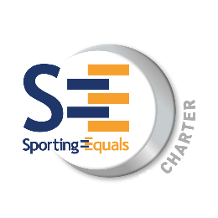
Hearing
Mobility
Learning
Physical
Visual
Multiple
Other
Prefer not to say

