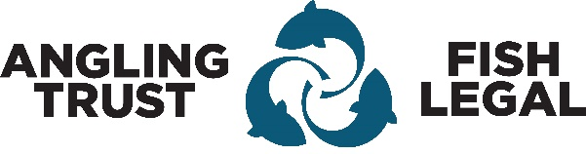
Angling Trust Risk Assessment

Activity |  | Location |  | Brief Description of the Activity
Risk No | Risk Description  (Context and Consequence) | Cause | Risk Status | Mitigation | Action Owner | Risk Status
1

2

3

4

5

Angling Trust Risk Assessment
Risk No | Risk Description  (Context and Consequence) | Cause | Risk Status | Mitigation | Action Owner | Risk Status
6

7

8

9

10

Assessment Carried Out By (Print Name) | Signature | State How Users Have Been Informed | Date Issued

Example
Risk No. | Risk description  (Context and Consequence) | Cause | Risk  Status | Mitigation | Action  Owner | Risk Status
1 | Drowning | Fall overboard from a boat. | High | - Do not stand up in a boat  - Wear a life jacket |  | Low
Carry out an assessment of the Hazards you might encounter whilst carrying out your activity, think about the cause and how you might reduce or mitigate the risk by taking an action. This can be completed as an individual but is best carried out as a group who might have the knowledge and experience in the activity you are assessing. Obviously the most effective prevention is not to carry out the activity. But by applying sensible and practical measures the risk can be reduced to an acceptable level. A simple example below demonstrates.

The next, and equally important step is to determine how you inform all those involved in the activity of the Mitigation measures. This could simply be done by carrying out a briefing just before the activity. If this is a repeat activity then you might consider producing a set of rules for this activity, for instance.
Boat Angling, you must not stand up in a boat and you must wear a life jacket.
It is pointless developing a first-class Risk Assessment if you do not inform the people involved of the mitigation measures or actions. If necessary, use the Action Owner column to identify who needs to take responsibility for the action.
The Risk Assessment can be handwritten or completed electronically. To increase the row width for a handwritten version simply place the cursor in the row and ‘enter’
Likelihood |  | Impact
1 = Very unlikely |  | 1 = Insignificant
2 = Unlikely |  | 2 = Minor
3 = Possible |  | 3 = Significant
4 = Quite likely |  | 4 = Serious
5 = Very likely |  | 5 = Severe
The table below is simply a guide to help you define the risk category, Low, Medium, High. It is not a scientific calculation but just a generalisation based on perception. These categories or colours merely act as a guide to indicate which Risks may need monitoring or further investigation, and action in the way of mitigation. To assess the Risk Status simply multiply the Likelihood rating by the Impact rating and use the table below. For handwritten assessments use High Medium or Low.
Green - Low Amber - Medium Red – High
 | Likelihood
Impact | 1 | 2 | 3 | 4 | 5
 | 2 | 4 | 6 | 8 | 10
 | 3 | 6 | 9 | 12 | 15
 | 4 | 8 | 12 | 16 | 20
 | 5 | 10 | 15 | 20 | 25

