Guide to implement biosecurity to prevent invasive species introduction for fisheries and clubs
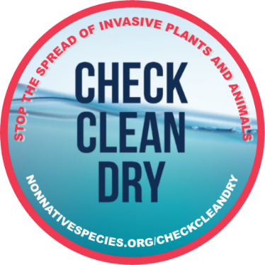

Contents
Foreword 2
What is biosecurity? 2
Check, Clean, Dry 3
Wash down stations 3
Which biosecurity facility is the most suitable for my site? 4
1. Hot water wash down stations 5
2. Cold water wash down stations pressure washers 5
3. Wash downs in locations without clean water 6
4. Disinfectant 6
Factors that need to be considered during the development of a biosecurity wash down station. 7
1. Location for the wash down 7
2. Access to utilities 7
a) Access to clean water 8
b) Electric 8
3. Containment of material and ‘contaminated’ water 8
a) Base of the drainage area 8
b) Barrier at the boundary of the wash down area to contain water and spray. 10
c) Drainage 10
Types of soakaway 11
The size of the soakaway 12

Foreword
The guidance outlined within provides advice on measures that can be implemented in freshwater environments to control invasive species and prevent the introduction of new species to a venue.
The best approach will vary according to your site, so this document should be used as a guide. You should seek further advice from our Environment Officers, and/or an independent consultant.

What is biosecurity?
Biosecurity is the collective term used for measures that are put in place to protect against the introduction or spread of invasive non-native species into, or from, a site. These can include a variety of measures such as requiring anglers to clean and dry their equipment when they arrive onsite, raising awareness of invasive species and ensuring native plants are used in habitat conservation projects. These measures should be imbedded into all practices that are being undertaken at a fishery to protect the venue from the accidental introduction of invasive species.

Check, Clean, Dry
A key measure that should be endorsed by every fishery and club is that members, visitors, and contractors follow Check, Clean, Dry.
CHECK – nets, stink bags and clothing at the bank side for mud, aquatic animals or plant material. Remove anything you find and leave it at the site.
CLEAN – any angling equipment or clothing that has come into contact with water, paying particular attention to the rims of nets, tread of boots, unhooking mats and stink bags. Ideally where possible use hot water to clean your gear as 45 °C has been found to be highly effective at killing invasive species. If this is not available then use Virkon Aquatic disinfectant, and as a final option cold water under pressure. This should be done at the site where possible, or when you return home.
DRY – your angling equipment and clothing for at least 24 hours in sunlight. This is a crucial final step to kill any remaining invasive species and fish diseaes that may remain on your kit but cannot be seen with the naked eye.
These three easy steps have been found to be 99% effective at killing invasive non-native species and diseases trapped within damp recreational gear. They will also help your fishery avoid unwanted fish diseases.
Our biosecurity risk assessment (free to download on our AT INNS page) provides more information on measures that can be incorporated into fishery management practices, and includes but is not limited to:
- Installation of Check, Clean, Dry signs at entry points
- Using native plant species for habitat improvements e.g., fish refuges, marginal vegetation
- Provision of keep nets to anglers
- Installation of wash down facilities

Before applying to the AIF, every fishery should have Check, Clean, Dry signage in place at all their fisheries and have completed:
a) the biosecurity risk assessment template (please select the appropriate assessment ‘fishery’, ‘river/canal’ or ‘catchment’ based on your project
b) modules 1 and 3a of the free e-learning on the GB Non-native Species Secretariat website

Wash down stations

By providing wash down stations on site, a fishery and club can ensure anglers can implement biosecurity when they visit/ leave the water, reducing the risk of invasive non-native species being introduced into, or spread from, the site. Biosecurity should be undertaken after every fishing trip. Ideally this should be done before leaving a site, or immediately on return home. However, it is recognised this is not always possible. By having a wash down station available on site, this will provide an opportunity for anglers that have been unable to clean their kit to do so on arrival.
There are several different types of ‘wash down station’ available, and their suitability will depend on the space and utilities accessible at your site.

Which biosecurity facility is the most suitable for my site?

The type of facility that could be installed at a fishery will depend on several factors, but critically depends on whether there is access to clean water and/ or electric. Based on this, there are different options available to a club or fishery from a full wash station which includes a soakaway, through to a dip tank or boot wash.
Types of facilities:
- Hot water wash down station (using an adapted hose pressure nozzle, pressure washer, or immersion in hot water)
- Cold water wash down station (using an adapted hose pressure nozzle, pressure washer with bowsers)
- Disinfectant sprays or dip tanks
- Provide anglers with keep nets/ other items of equipment that stay at the venue
Contact your Environment Officer for advice on the most suitable option for your venue.

The flow chart below will help to identify which facility is most suitable for a site.

1. Hot water wash down stations
Hot water is the most effective approach to managing invasive non-native species. There are two types of hot water wash down facilities that could be installed:
- Sites that have access to a hot water tap.
A hose with a high pressure nozzle can be used from the hot water tap and used by anglers to spray or immerse their equipment. A minimum temperature of at least 45 °C for 15 minutes is required to kill invasive species. Many hot taps within a home achieve this temperature minimum temperature threshold when they are running for a few minutes. It is therefore recommended that anglers immerse their angling gear and leave it for a few minutes whilst they are packing the remainder of their equipment away, or whilst they are setting up at their swim.
- Sites with no hot tap, but access to an electric source and clean water supply.
Aa water pressure washer with the capacity to heat water can be attached to the clean water supply for anglers to use. A temperature of 60 °C should be used to account for cooling as the water leaves the hose nozzle before making contact with the contaminated equipment. Due to hot temperatures, extreme caution would be needed using hot water pressure washers. It is recommended that these would only be used following training provided to members for safe use. If training is not available, it is recommended that a cold water pressure washer is used applying cleaning at high pressure.

2. Cold water wash down stations pressure washers
Cold water is not effective at killing invasive species. Therefore, where hot water is not available, cold water wash downs with should be installed that clean equipment under high water pressure. The high pressure will dislodge any mud, plant material and animals from angling nets, boots and stink bags. It does not kill the species (with the exception of some research found on plant fragments), but it will remove the material from angling gear.
Pressure washers can run from the mains where an electric point is available, or on battery or diesel are in remote locations. This provides the option to set up wash down stations in areas that do not have an electric point but will require more frequent checks. These may be useful when a fishery is running a competition or undertaking habitat management and need to clean equipment.
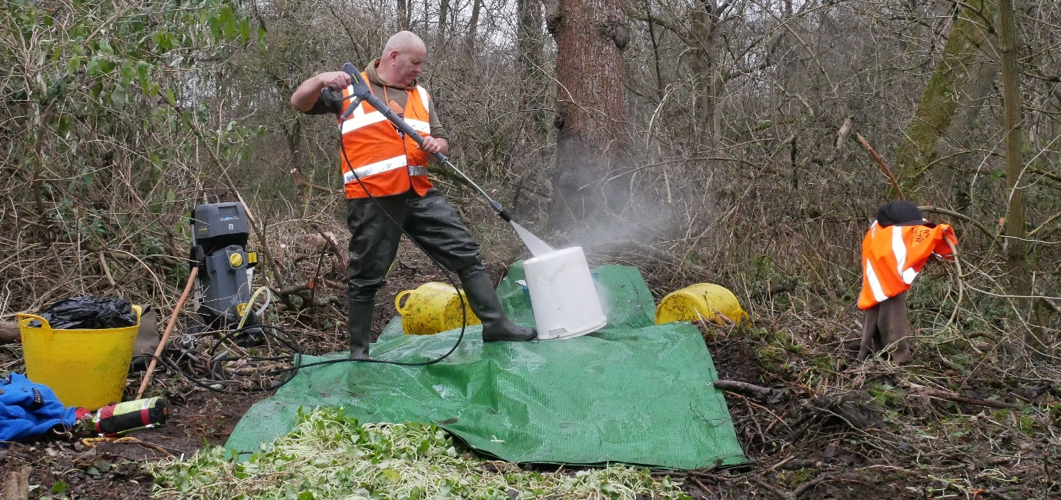
Image: Using a pressure washer to clean kit after removing Floating Pennywort from a water in the Colne Valley

3. Wash downs in locations without clean water
At sites where no clean water is available, bowsers can be used to provide clean water on site. These can be linked to a hose or a pressure washer to enable wash down facilities to be provided on site. Depending on the volume of anglers visiting the site, the bowser will require refilling at varying frequencies. Thus, this option may be suitable to provide temporary wash down facilities for high-risk events such as competitions or undertaking invasive species management. Using a bowser alongside a battery powered pressure washer provides the flexibility to set up a wash down station in different locations.

4. Disinfectant
Virkon Aquatic solution and other disinfectants have been put in place at fisheries to reduce the risk of introducing fish diseases. Disinfectants made to the correct concentrations and frequently changed can also be highly effective at tackling some invasive species. Concentrations should be made to at least 1% concentrations and replaced at least every 3-5 days based on frequency of use or as per the manufacturer’s guidelines. Disinfectant should be left in a container with a lid to prevent dilution by rainwater.
Where disinfectant is used, care must be given to the correct disposal of the contaminated material as per the manufacturer’s guidelines. This should be undertaken at least 100m away from a waterbody and should not be placed down a storm water drain. Ideally it should be drained over hard standing gravel, or over vegetation. Ideally the disinfectant should be left to degrade for as long as possible before disposal.
Disinfectant can be applied by directly spraying onto equipment, or immersing equipment in a container containing the disinfectant.
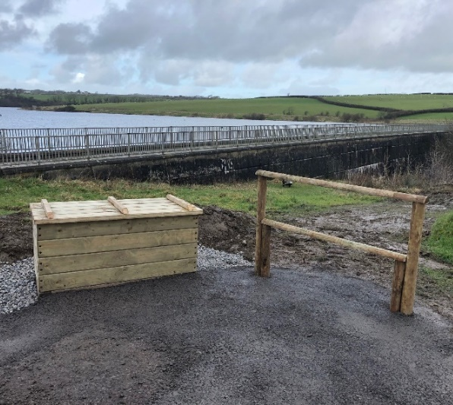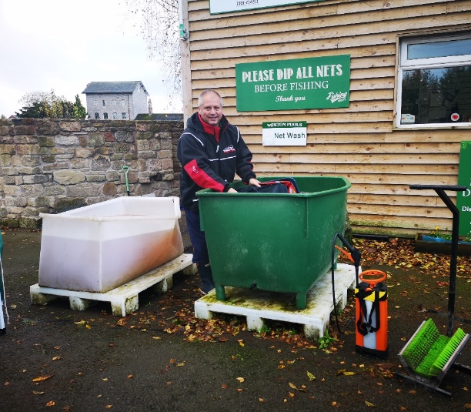
Image credit – Above: South West Water, Right: Weston Pools

Factors that need to be considered during the development of a biosecurity wash down station.

Location for the wash down
Consider the most suitable location to host a wash down station so that it will be used by anglers coming to the fishery. This should be:
- placed in the car park, on an entry point to the water, or at a suitable alternative point such as the hut or near toilets to ensure the station isaccessible to anglers to use upon entry or exit of the site.
- a suitable distance away from any waters (including the fishery/club water but also any other nearby waterbodies such as ditches or streams) to ensure any invasive species material and ‘contaminated’ water does not pose a risk of being washed off into a nearby waterbody.
- Large enough to host a wash down facility – consider the size of the equipment that will be used to provide an area large enough for anglers to enter and move around freely with their kit.

Access to utilities
To determine what facilities you can install on site, consider what utilities you have available that you can use to develop an effective wash down facility, and where these are located in relation to your site and where you would like to place your wash down facility.

Access to clean water
Is there a tap present on site or another sufficient clean water source which you can use to provide clean water to use for the wash down station? Is the access to both hot water and cold water or is only one available?
If this is not available, do you have the storage available to collect rainwater to use as part of a wash down station, or keep a water bowser? If there is space for these, this might present options to allow you to provide wash down stations for high participation events.
Alongside this, you could look into providing angling equipment such as keep nets which will remain on site to reduce the number of items that are being brought onto the fishery.

Electric
Access to an electric point on site provides the opportunity to power a pressure washer to help dislodge invasive species from equipment Where electric points are not available, using a hose adaptor provides an alternative way to provide water under high pressure for use on site.

Containment of material and ‘contaminated’ water
An important factor that needs to be considered in the development of a wash down station is how to collect and contain any mud and plant material that is washed off from angling equipment alongside the potentially large volume of ‘contaminated’ water. This water cannot be allowed to flow directly back into the water system as this would allow the introduction of invasive non-native species and diseases into the water. For similar reasons, the water cannot be directed to outdoor drains.
There are three areas that need to be considered in the design of a bio-secure wash down area to ensure contaminated material and water are contained. These are the: a) design of the base of the wash down; b) barriers to contain water spray and c) drainage.

Base of the drainage area
Depending on your fishery and the equipment being used by your members a free standing container or a ‘walk-in station’ might be more appropriate. Where a container is being used, it is important to consider the depth and width of the structure to ensure it is large enough for equipment to be placed and moved for easy cleaning. Similarly, where a ‘walk-in station’ is used the size and height of the station walls need to be considered.

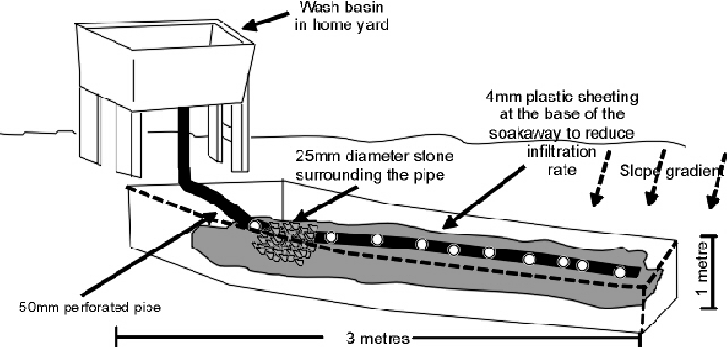
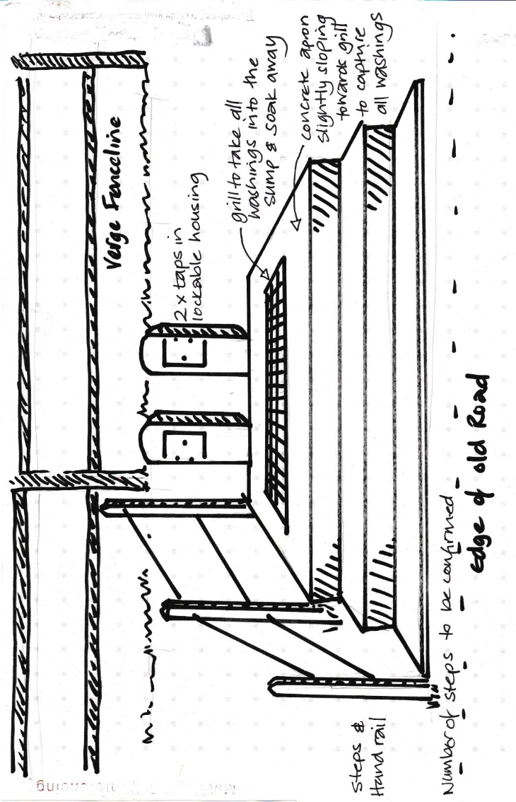
Image: Top: Potential design for a soakaway with a wash basin (Credit: Armitage et al. 2009)
Bottom: Potential design for a soakaway with drainage in the floor (Credit: Essex and Suffolk Water Company)

A variety of different surfaces are available that can be used for the base of a ‘walk in’ wash down station:
- A non-slip surface should be chosen, such as concrete with rake groves added towards the drainage point, or a drain structure which covers the wash down area.
- Where concrete or an impermeable substrate is used, this should be sloped towards the drainage point to prevent stagnant water or collection of material on the surface
- It is not recommended that this is permanently undertaken on grass as this will become muddy following frequent use. Gravel may present a suitable option, but it should be noted that the gravel material will become contaminated.
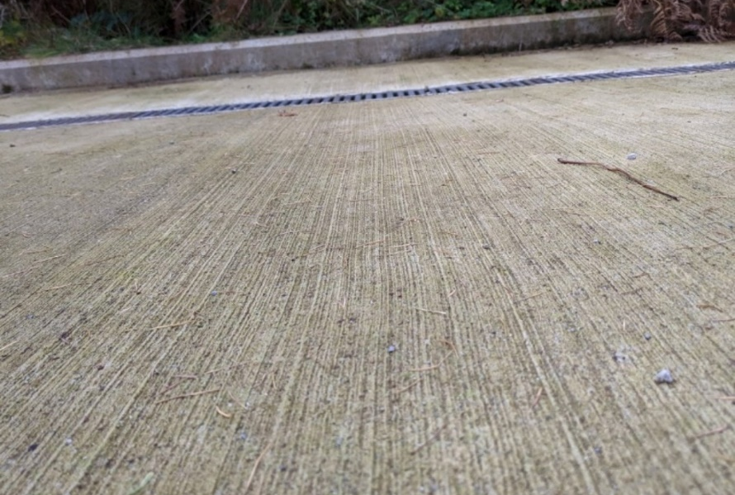
Image: Example of concrete with rake markings sloping towards the drainage point.
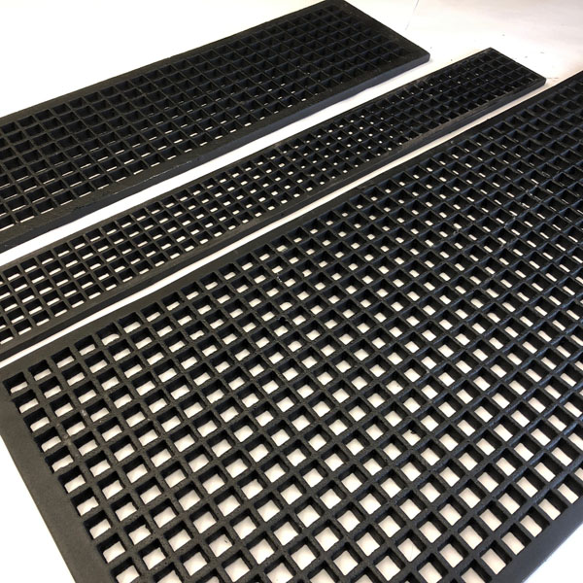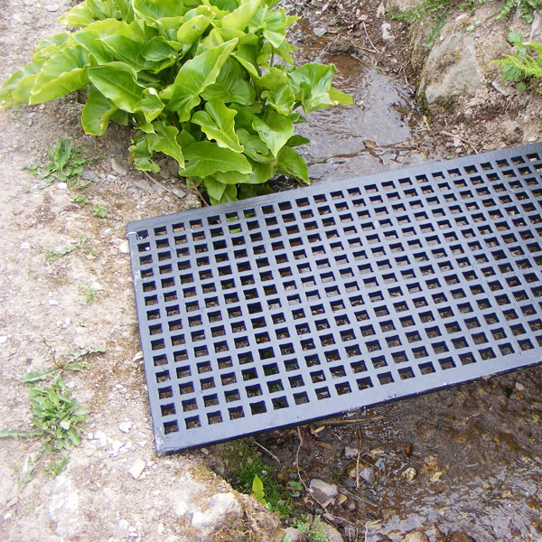
Image: Example of large gratings that can be used for the base of the wash down facility. This allows free movement of the water and material to a contained area below. These grates should be fixed so they can be lifted and cleaned.

Barrier at the boundary of the wash down area to contain water and spray.
This could be a small lip and/ or low wall (waist height) at the edge to contain spray. If you do have a lip, this may need to be sprayed in hazard colours to minimise a trip hazard. The lip or low wall does not need to be on all sides of the wash down area, but should be present on the downslope area, and on areas closest to a waterbody. Having a low wall will allow the angler to move freely within the wash down with their equipment.
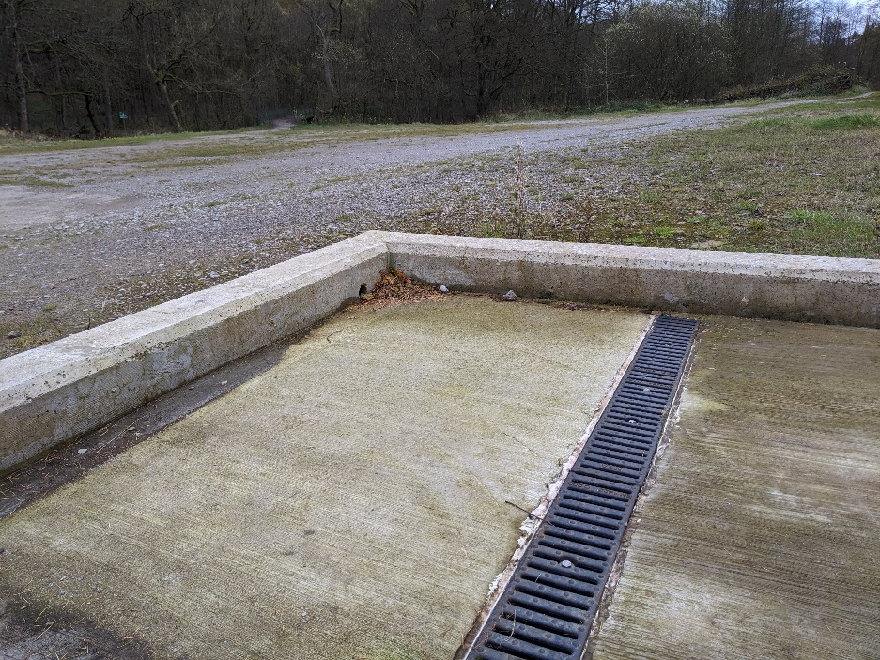

Drainage
Drainage is one of the most critical elements to consider for your wash down. The ‘contaminated’ water cannot enter surface drains as this presents a risk of untreated water entering storm overflows, spreading invasive non-native species into river systems.
Water needs to soakaway on site. Where permanent wash downs are being considered a soakaway should be included within the design to allow invasive species material to be collected, and the water to drain away through groundwater.

Considerations for a soakaway
- The depth of the water table. Dig an exploratory pit if required to ensure the water table is well below the intended site for the soakaway.
- The soil type - Soakaways rarely work when dug out in heavy clays as clay soils do not allow water to pass through, instead water collects like a pond. In these places, it may be better to explore other options which use lower volumes of water.
- Distance from buildings. If you are considering installing a soakaway it should be 5m away from any buildings
- Calculate the required storage volume
- Consider space requirements
- Ability to access the drain for maintenance and removal of material
- The soakaway is sunk lower than the area being drained so that the drains slope towards the soakaway.

Specifications for the soakaway:
- Pipe flowing into soakaways should be at least 75mm diameter which is the minimum pipe size for any surface water drainage. 100mm recommended size.
- Soakaway pipe should be laid to a fall of 1 in 40. i.e., for every 4m of pipework the trench should slope down by 100mm. Keep the run as short and straight as possible
- The soakaway should be a minimum of 1m x 1m x 1m with at least a 1m depth below the bottom of the incoming pipe.
- The size of the soakaway will depend on how much water the soakaway will be processing and the percolation rate of the surrounding soil i.e., how quickly the water will soak into the soil around the soakaway.
- The hardcore (stone infill) should completely surround the pipe and finish approximately 100mm above it.
- Where you are using soakaway crates these should be covered with a tough but porous material such as a geotextile membrane. This will allow water to pass into the crate but will prevent the crate being filled with soil and sediment.
- The floor layer for the wash down station can then be placed on top of this. This should include a drain to capture the contaminated water from the drainage pipe.
- Critically, the soakaway should not come into contact with the water table and have sufficient drainage capacity.

Types of soakaway

Basic soakaway:
- Dig a large hole, line with heavy duty landscaping fabric to keep the earth from over time clogging up the gravel.
- Dig the trenches that are discharging into the soakaway ensuring adequate fall along the entire length.
- Connect the trenches to flow into the hole. Tidy up the soak away and trenches by removing any loose soil that has fallen in.

Soakaway crates:
There are quite a few soakaway crate options on the market, sometimes referred to as Aquablocks, water blocks of soakaway drainage crates.
These products effectively take the place of the rubble infill in the soakaway pit. They look very similar to large milk crates but with a bit more constructive stability and are purchased in a flat pack form that clip together to form a box shape.
Different colours sometimes signify where they can be used but this can vary according to the manufacturer. Green soakaway crates can be used in non-traffic areas (as they are not built to take the weight of a vehicle) and are most likely to be relevant for biosecurity wash down stations. Blue crates can be used in areas such as under driveways as they can take the weight of a vehicle.
Crates can save time and effort as you will not then have to transport the rubble from source to your soakaway pit. They are also a benefit in ensuring you get the correct permeability for the soakaway. However, they can be quite expensive compared to the cost of using traditional methods, especially if you already have the required materials available.
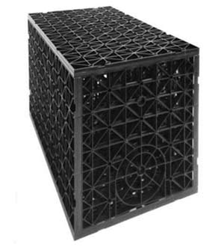

The size of the soakaway

This will depend substantially only the volume of anglers that are coming to the site. Getting the size of the drainage area correct to be able to handle the volume of water is important.

A worked example is provided in the box below to demonstrate how to calculate the volume of the soakaway. However, it is strongly recommended that expert advice in sort to assist in the design of a soakaway as every fishery is different and therefore parameters for the soakaway are likely to differ.

Example of calculating the size of the soakaway

This formula below has been used to develop soakaways for building structures and is a guideline to calculate the volume of the soakaway and should be suitable for most situations.
- C= (AxR)/3
Where C is the capacity or volume of the soakaway in m3
A is the area of drainage area in m2
R is the volume of water used by an angler in m/h (metres / hour).

e.g. example for calculating soakaway size
For a pressure washer 2000mm per hour of water could be used which equates to 2.00m/h. Using this formula we can quickly calculate the size of the soakaway that needs to be installed. Say we have a wash down basin area of 4 m2 and we use the water used by an angler of 2.0 m/h the calculation is as follows:
- C=(4x2.0)/3
- C=(8)/3
- C=2.67 m3

Image: A potential design of a soakaway with pipe inflow and inspection cover for maintenance (Credit: Chen and Stevenson, 2008)

