Guide to control invasive species for fisheries and clubs

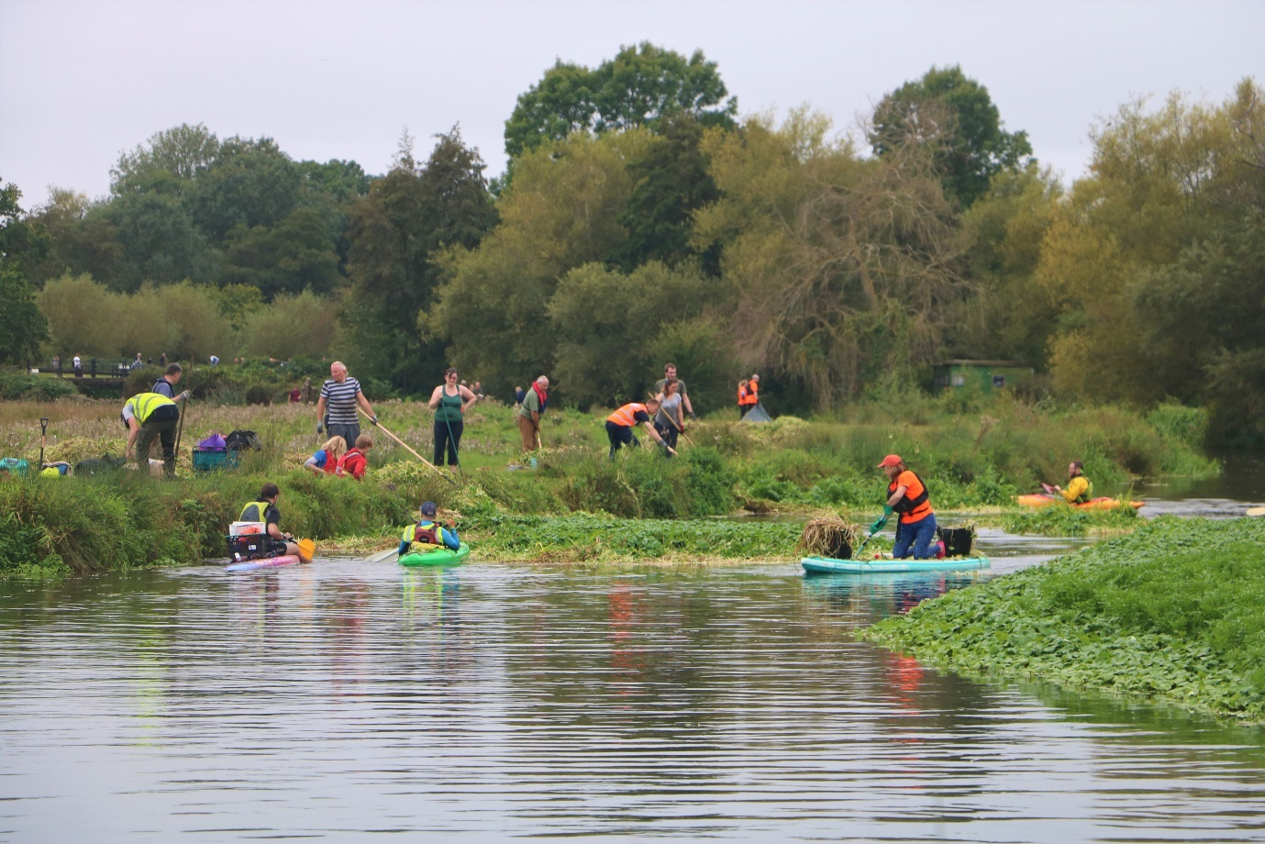

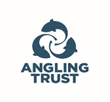

Contents
Foreword 2
Why? 3
How can I manage invasive species? 4
How to control species that are already present at your water? 4
Manual control 4
Chemical control 5
Biocontrol 6
Biosecurity measures to prevent invasive species being introduced 7

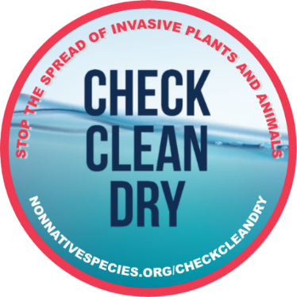

Foreword
The guidance outlined within provides advice on measures that can be implemented in freshwater environments to control invasive species and prevent the introduction of new species to a venue.
The best approach will vary according to your site, so this document should be used as a guide. You should seek further advice from our Environment Officers, and/or an independent consultant.

Why?

Invasive non-native species are animals, plants or diseases that have been introduced by human activity outside of their native range and cause significant negative environmental, social and economic impacts on the habitats where they are introduced.
They present one of the five top reasons for biodiversity loss worldwide, cost the UK economy at least £1.8 billion a year, and present a major threat to fish populations and the angling sector. Invasive species, can outcompete and predate on native fish populations, reduce water quality, degrade spawning areas and can inhibit angling access. In worst case scenarios it can result in the temporary or permanent closure of a fishery where species are invaded.
Invasive non-native species can be introduced by humans to a site either intentionally, or by accident. One of the major risks to waterways including fisheries is the accidental introduction of invasive non-native species into waters stowed away within damp angling equipment. Nets, waders and stink bags in particular present a substantial risk with research indicating invasive species can survive for at least 14 days within uncleaned angling gear, and can establish from single plant fragments or a few individual insects.
Prevention is the most effective and cost-efficient approach to managing invasive species in the long term and protecting fisheries and fish stocks. The term ‘biosecurity’ refers to a series of measures that can be put in place to minimise the risk of invasive species being introduced to, or from to a site.
Implementing these measures will also help protect fisheries from fish diseases and parasites such as Gyrodactylus which is causing heavy losses in wild Atlantic salmon stocks in Norway, and Koi-herpes Virus (KHV) which can spread through uncleaned nets, unhooking mats and boots.

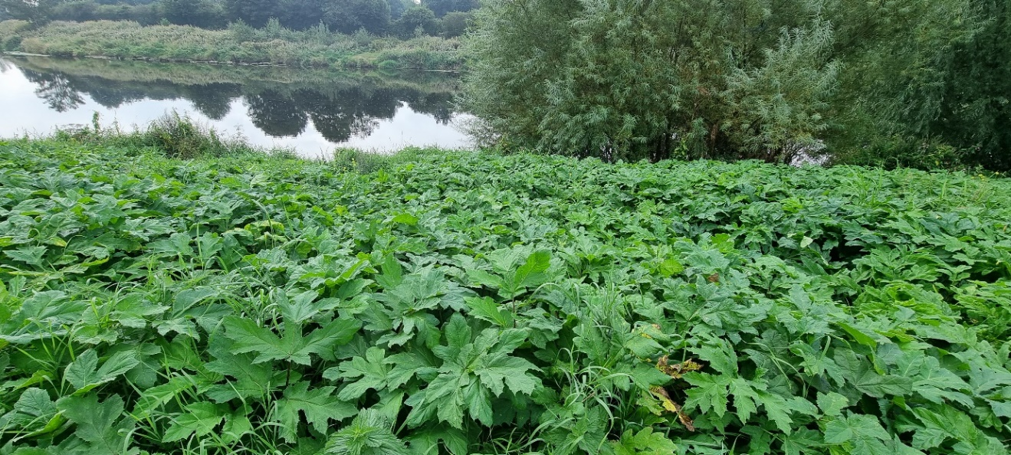
Image: Giant hogweed on the riverbank. If bare skin comes into contact with the plant sap it can result in burns and blisters

How can I manage invasive species?

To manage invasive species, clubs should:
a. Control invasive species that they already have at their venue (See page 5)
b. Implement biosecurity measures to minimise the risk of new invasive species being introduced to their venue (see our separate ‘Biosecurity guide’)

How to control species that are already present at your water?

There are four main methods available to control invasive species present at your water:
1. Mechanical removal – hiring contractors with machinery to remove species
2. Physical removal – using volunteers and organising working parties to remove species
3. Chemical control – applying licenced chemicals, often over multiple treatments to control species
4. Biocontrol – releasing natural predators to target the invasive species. These will have undergone extensive testing in the laboratory by the Centre of Agriculture and Bioscience International (CABI) to ensure they are target-specific and safe for use.
The most appropriate method will vary according to the invasive species, their abundance on your site (e.g., dense population or newly established) and the specific environmental conditions of your site. The best approach will also vary over time, and it can be effective to combine methods to increase impact.
It is essential that good biosecurity is incorporated into invasive species management to prevent the spread of invasive species from the site. This includes measures such as cleaning equipment and clothing, minimising, and collecting plant fragments, and starting management upstream and working downstream.
Manual and chemical removal present the key options for clubs to undertake repeated action to control invasive species.

Manual control
Manual control involves the use of volunteers and members to physically control invasive species. This can include techniques such as hand pulling, cutting and digging. Manual removal can be useful for species such as Floating Pennywort and Himalayan balsam but are not suitable for other species such as Giant Hogweed.
Equipment:
The equipment you will need will vary according to the invasive species you wish to control. A non-exhaustive list is outlined below:
- Throw rakes
- Hand rakes
- Tarpaulin
- Personal protective equipment
- Long handled nets
- Booms
- Approved mink traps with otter guards

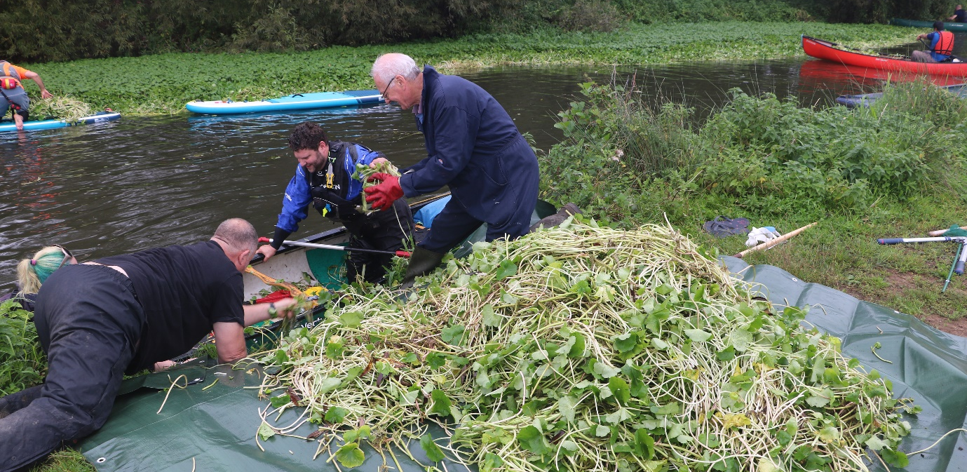
Image: Volunteers removing Floating pennywort from a stretch of the River Wey.

Chemical control
This approach uses chemicals to eradicate or limit the growth of invasive species and can be target or non-target specific. In Great Britain, the only chemical that is currently licenced for use on or near water to treat invasive species is glyphosate. Chemical control can be useful for species such as Giant Hogweed and Japanese Knotweed.

This approach will often require multiple treatments and relies on the appropriate weather condition to ensure sufficient the target species receives sufficient exposure to the chemical.

For your club to use chemicals to treat invasive species, it is essential that someone has undertaken the relevant training courses. You can apply to send someone on training through the Angling Improvement Fund.

These courses may include:
PA1 – Handling and Application of Pesticides
PA6a – Safe application of pesticides using handheld equipment
PA6aw - Safe use of pesticides to or near water
PA6 INJ – Safe operation of handheld stem injection equipment

The PA1 course must be completed before the handheld application and safe use modules are undertaken.

Once you have completed your application, before any spraying can take place near water you will need to complete a AqHerb01 form to obtain a licence to use herbicides in or near water:
https://www.gov.uk/government/publications/application-to-use-herbicides-in-or-near-water

Equipment to undertake chemical control:
The equipment you will need will vary according to the invasive species you wish to control. A non-exhaustive list is outlined below:
- Personal protective equipment
- Knapsack sprayer
- Stem injector kit
- Handheld spraying units

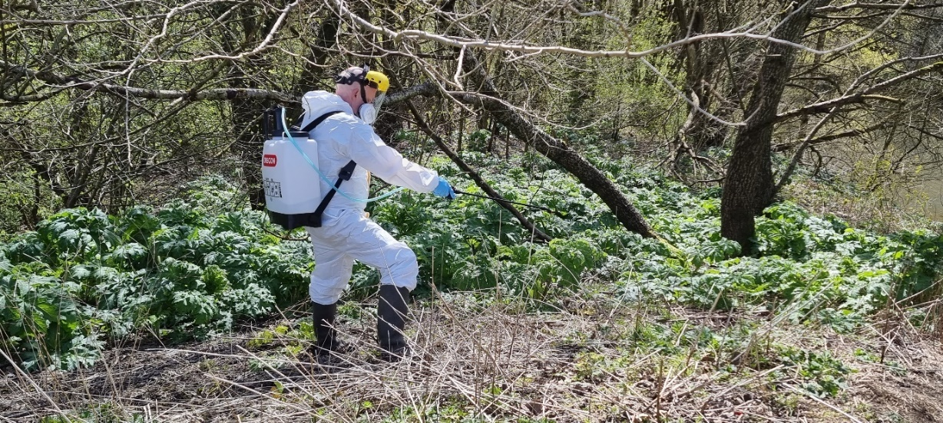
Image: Club treating Giant hogweed through chemical application.

Biocontrol
Biocontrol or biological control involves the release of living organisms, such as insects or pathogens, to target specific invasive species. It involves years of extensive research to identify specialist natural enemies of the invasive species which can be released that will control the invasive species but will not impact our native species.
There are several species that have been released into Great Britain. At this stage, many of these are still undergoing monitoring to determine their success and therefore cannot be purchased by angling clubs.
However, there is the opportunity to purchase a weevil for use against the invasive plant, Water fern (Azolla filiculoides). These can be purchased online and will be delivered by post.
https://www.azollacontrol.com/

Biosecurity measures to prevent invasive species being introduced

Although this might sound alarming there are some very effective simple steps that can be put in place to minimise the risk of invasive species being introduced. These suites of measures are collectively referred to as ‘biosecurity’ and should be imbedded in all practices that are being undertaken at a fishery.
A key measure that should be endorsed by every fishery and club is that members, visitors, and contractors follow Check, Clean, Dry.
CHECK – nets, stink bags and clothing at the bank side for mud, aquatic animals or plant material. Remove anything you find and leave it at the site.
CLEAN – any angling equipment or clothing that has come into contact with water, paying particular attention to the rims of nets, tread of boots, unhooking mats and stink bags. Ideally where possible use hot water to clean your gear as 45 °C has been found to be highly effective at killing invasive species. If this is not available then use Virkon Aquatic disinfectant, and as a final option cold water under pressure. This should be done at the site where possible, or when you return home.
DRY – your angling equipment and clothing for at least 24 hours in sunlight. This is a crucial final step to kill any remaining invasive species that may remain on your kit but cannot be seen with the naked eye.
These three easy steps have been found to be 99% effective at killing invasive non-native species and diseases trapped within damp recreational gear. They will also help your fishery avoid unwanted fish diseases.
Our biosecurity risk assessment (free to download on our AT INNS page) provides more information on measures that can be incorporated into fishery management practices, and includes but is not limited to:
- Installation of Check, Clean, Dry signs at entry points
- Using native plant species for habitat improvements e.g., fish refuges, marginal vegetation
- Provision of keep nets to anglers
- Installation of wash down facilities

Before applying to the AIF, every fishery should have Check, Clean, Dry signage in place at all their fisheries and have completed:
a) the biosecurity risk assessment template (please select the appropriate assessment ‘fishery’, ‘river/canal’ or ‘catchment’ based on your project
b) modules 1 and 3a of the free e-learning on the GB Non-native Species Secretariat website

