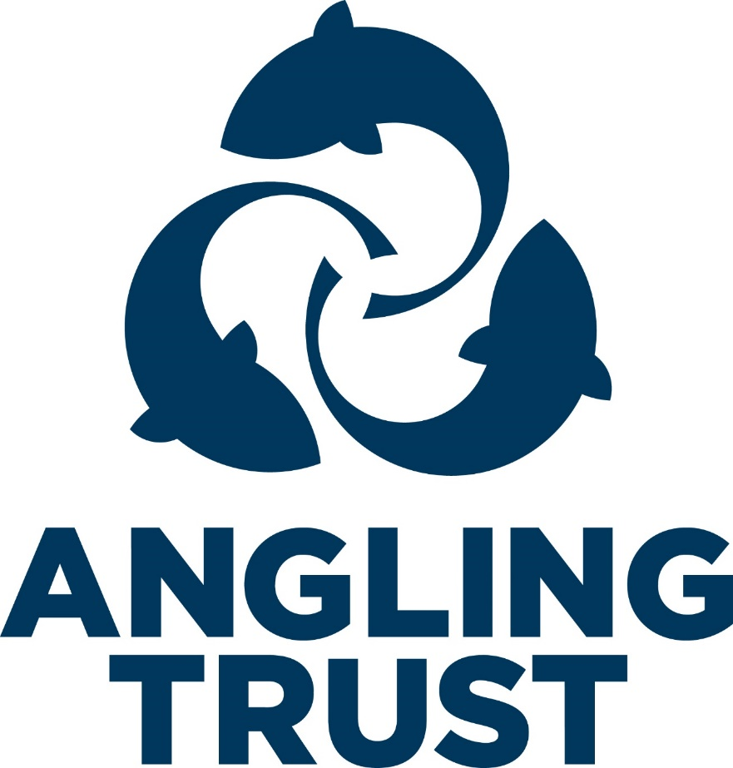

________________________________
Angling Trust
Document No
Safeguarding Adults Guidance

DOCUMENT CONTROL

Version Number |  |  | No 1
Document Owner |  |  | Richard Hadley
Lead Director |  |  | Sarah Collins
Review Frequency |  |  | Yearly
Next Review Date

REVISION HISTORY

Version | Date |  |  | Summary of Changes |  |  |  | Author
1 | 22nd March 2023 |  |  | New Document |  |  |  | Richard Hadley
Approvals
Approved by: ATB/FLC/CEO/COO/GOV COMM |  |  |  |  |  | Date |  | Version
Distribution
Audience |  | Method |  |  | By whom |  | Date of issue |  | Version

About this document
- This guidance document should be used along with the Angling Trust Safeguarding Adults Policy
This document aims to provide you with: wording, further information, suggestions and links to help support the Angling Trust’s Adult Safeguarding Policy
- Further information is available on the Ann Craft Trust website, which can be used to provide additional information to each section
- A comprehensive Safeguarding Adults Procedures document should be referred to and can be used in conjunction with this guidance.
- The information contained in this document is correct at the time of publication.

Contents
Raising and Managing a Concern—example flowchart Policy
- Mission Statement
- Policy Statement
- Scope
- Purpose
- Implementation
- Legislation Procedures
- Whistleblowing
- Recording and Storing Information
Sources of Information and Support
Links to other information, procedures and templates

Raising and Managing a Concern

Anglin Trust Flowchart for Raising and Managing a Concern

Are you concerned about
a) Yourself or another adult or b) the behaviour of a staff
member/volunteer
Yourself or another adult
Behaviour of the Angling Trust Staff.
Are either of you at immediate risk of harm right
now? Or has a criminal offence been committed?
Are either of you at immediate risk of harm now?
NO
YES
Share your concerns with the
Safeguarding Lead (DSL).
Seek help by dialling 999
for police or ambulance.
The Safeguarding Lead (DSL) will then follow the
NO
Detail here who to contact. e.g.
- NGB
- Centre manager
- Police
- Active Partnership
safeguarding procedures

Supporting the adult through the process

The Safeguarding Lead (DSL) should:
- Speak with the adult concerned.
- Determine the wishes of the adult concerned to ensure the process is person led and outcome focused.
- Seek external guidance and advice as appropriate (this could include Active Partnership or Ann Craft Trust)
- Offer support and information for the adult concerned to make informed choices.
- Put measures in place to keep the adult safe during the activity (if appropriate)
- Ask for consent to report the concern to statutory agencies if appropriate.
- Keep the adult informed and involved throughout the process.

Policy

Our Statement (Our promise)
The Angling Trust will strive to create a culture where everyone is welcome. We will listen respectfully and commit to promote the welfare and safety of all. We will ensure that safeguarding practice reflects statutory responsibilities, government guidance and complies with best practice.
We acknowledge that the interests of children and vulnerable adults are paramount and that everyone can have a positive experience of angling and are protected from abuse while participating.

Scope

This safeguarding adult policy and associated procedures apply to all individuals involved in The Angling Trust including participants, staff, coaches, volunteers and to all concerns about the safety of adults whilst taking part in Angling Trust activities and in the wider community.

Purpose
The purpose of this policy is to demonstrate the commitment of The Angling Trust to
safeguarding adults and to ensure that everyone involved in angling trust events and activities are aware of:
- The legislation, policy and procedures for safeguarding adults.
- Their role and responsibility for safeguarding adults.
- What to do or who to speak to if they have a concern relating to the welfare or wellbeing of an adult within the organisation.

Implementation

- The Angling Trust follows safe recruitment procedures when employing staff and volunteers. This includes a DBS check if appropriate.
- The committee will identify and appoint a Lead Safeguarding Officer and will notify members as who this is and how to contact them.
- All staff, committee member, volunteers have received safeguarding adults training.
- All activities include an assessment of, and risk to, the safety of all adults from abuse and neglect and designates a person who will be in attendance as a safeguarding lead for that event.
- All staff are aware of their role and responsibility and follow the code of conduct when
working with adults – ( Link to codes of conduct required)
- All staff are aware of the of the safeguarding reporting procedures and the importance of confidentiality.
- This policy is shared with all staff, committee members, volunteers and participants.
- This policy is reviewed on a annual basis.

Legislation

The Ann Craft Trust website details the key legislative information such as the relevant government Acts, definitions of abuse, statutory responsibilities and duty of care.
Summary:

In its wider context, safeguarding adults applies to everyone over the age of 18 and is about:
- protecting an adult’s right to live in safety, free from abuse and neglect.
- people and organisations working together to prevent and stop both the risks and experience of abuse and neglect, while at the same time making sure that the adult’s wellbeing is promoted taking fully into account their views, wishes, feelings and beliefs in deciding on any action.

The practices and procedures within this policy are based on the relevant legislation and government guidance which can be found here at Ann Craft Trust The key legislation and government initiatives,

Key Contact
Richard Hadley is the Designated Safeguarding Lead (DSL) who responsible for ensuring that this policy is adhered to. They will be responsible for the monitoring and recording of any safeguarding concerns and for ensuring that all concerns are shared with the appropriate authorities. It is not the role of the DSL to investigate, only to gather and share information as
appropriate. The Designated Safeguarding Lead (DSL) person can be contacted on richard.hadley@anglingtrust.net Tel: 07720974811

Raising a Concern
  - Any safeguarding concerns can be reported via My Concern or to a committee member or volunteer who will refer directly to the DSL..
  - Deputy DSL Darren Birch. Darren.birch@anglingtrust.net
  - Any concern that an adult is not safe is taken seriously, responded to promptly, and followed up.
  - The DSL will speak to the adult about the issue wherever possible, noting any views that the adult may have regarding how they wish the matter to be dealt and keeping them informed throughout the process.
  - The DSL may seek advice from external sources such as the local Safeguarding Adults Team, the Local Active Partnership, police or Ann Craft Trust.
  - The DSL will only share information with the people who need to know – such as the Safeguarding Adults Team, Police or local Active Partnership. Any referrals or passing on of information will be done with the consent of the adult wherever possible. If consent is withheld, but information is still passed on, the DSL will clearly document this and the reasons why. They will also inform the adult of this action wherever possible.
  - The DSL will make a written record of the concern and store it safely in line with Data Protection requirements.
Note:
  - If someone is injured or at immediate risk, immediate action should be taken. Seek help by dialing 999 for police or ambulance.

Whistleblowing

If the Safeguarding Lead or staff member is implicated or you think has a conflict of interest, then contact the Ann Craft Trust. www.anncrafttrust.co.uk

Recording and Information Sharing

All information will be stored in line with GDPR and Data protection. This will provided by Myconcern platform. (link to privacy and data policy)
Further Information can be found here: Reporting & Recording Safeguarding Issues - Ann Craft Trust
The Information Commissions Office (ICO) contains more information and a useful checklist for sole traders and sports clubs: How well do you comply with data protection law: an assessment for small business owners and sole traders | ICO

Sharing Information— We work to the Seven Golden Rules
- GDPR is not a barrier to sharing information.
- Be open and honest.
- Seek advice, if in doubt
- Share with consent where appropriate.
- Consider safety and wellbeing.

Necessary, proportionate, relevant, accurate, timely and secure.
Keep a record of your decision and reasons for sharing.
Sources of Information and Support

Action on Elder Abuse
A national organisation based in London. It aims to prevent the abuse of older people by raising awareness, encouraging education, promoting research and collecting and dis- seminating information.
Tel: 020 8765 7000
Email: enquiries@elderabuse.org.uk www.elderabuse.org.uk

Ann Craft Trust (ACT)
A national organisation providing information and advice about adult safeguarding. ACT have a specialist Safeguarding Adults in Sport and Activity team to support the sec- tor
Tel: 0115 951 5400
Email: Ann-Craft-Trust@nottingham.ac.uk www.anncrafttrust.org

Men’s Advice Line
For male domestic abuse survivors
Tel: 0808 801 0327

National LGBT+ Domestic Abuse Helpline
Tel: 0800 999 5428

National 24Hour Freephone Domestic Abuse Helplines

England | Northern Ireland
Tel: 0808 2000 247  www.nationaldahelpline.org.uk/Contact-us | Tel: 0808 802 1414  www.dsahelpline.org
Scotland | Wales
Tel: 0800 027 1234  Email: helpline@sdafmh.org.uk Web chat: sdafmh.org.uk | Llinell Gymorth Byw HebOfn/ Live free from fear helpline  Tel: 0808 8010 800  Type Talk: 18001 0808 801 0800  Text: 078600 77 333

Respond
Respond provides a range of services to victims and perpetrators of sexual abuse who have learning disabilities, and training and support to those working with them.
Tel: 020 7383 0700 or 0808 808 0700 (Helpline) www.respond.org.uk

Stop Hate Crime
Works to challenge all forms of Hate Crime and discrimination, based on any aspect of an individual’s identity. Stop Hate UK provides independent, confidential and accessible reporting and support for victims, witnesses and third parties.
Telephone: 0800 138 1625
Web Chat: www.stophateuk.org/talk-to-us/

Susy Lamplugh Trust
The Trust is a leading authority on personal safety. Its role is to minimise the damage caused to individuals and to society by aggression in all its forms – physical, verbal and psychological.
Tel: 020 83921839
Fax: 020 8392 1830
Email: info@suzylamplugh.org
www.suzylamplugh.org
Victim Support
Provides practical advice and help, emotional support and reassurance to those who have suffered the effects of a crime.
Tel: 0808 168 9111
www.victimsupport.com
Women’s Aid Federation of England and Wales
Women’s Aid is a national domestic violence charity. It also runs a domestic violence
online help service.
www.womensaid.org.uk/information-support

Links to other information templates, procedures

The Ann Craft Trust has also produced many resources to complement this policy which you
may want to include as an Appendix section or provide links to. Information includes:
- Terminologies and acronyms.
- A guide to common conditions,
- The key legislation and government initiatives, ,
- The safe recruitment process.

