Guide to Common Conditions
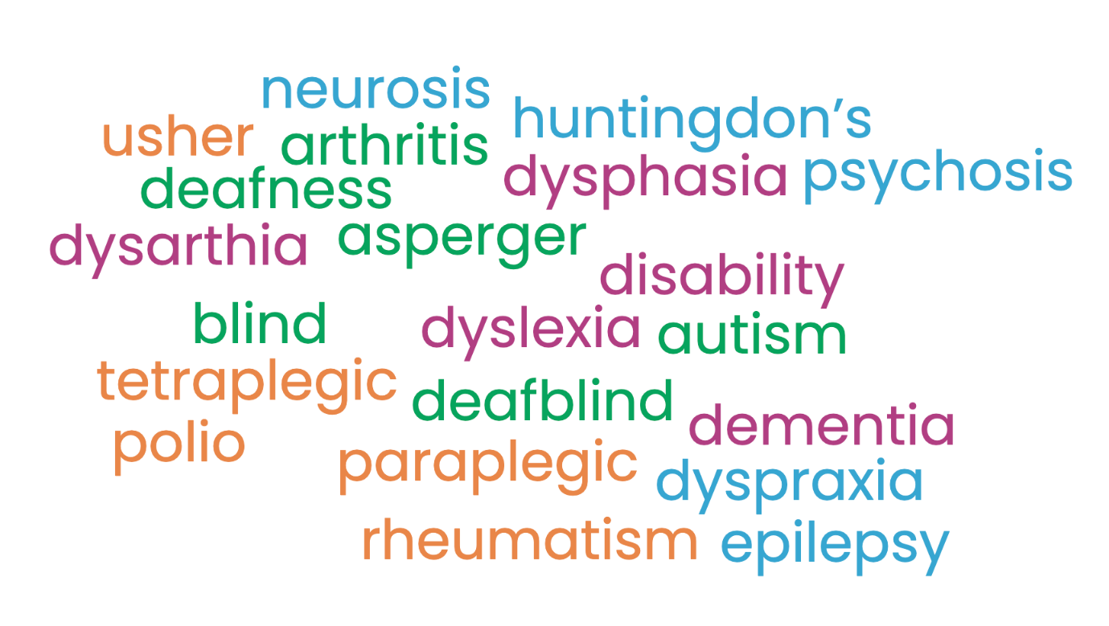
See our guide to common conditions to find out more about conditions such as arthritis, Asperger syndrome and Dysarthia.
Arthritis – A condition which deteriorates the bone and causes joint pain. The most common condition in the country.
Asperger Syndrome – Shares many of the same traits as autism, but certain traits, such as clumsiness, an almost obsessive interest in a hobby or collection and the love of routines, are typical of people with Asperger syndrome.
Autism – An abnormality of childhood development affecting language and social communication.
Profound blindness – As defined by the World Health Organisation, the inability to count fingers at a distance of ten feet or less.
Registered blind – Visual activity is 3/60 or worse, or 6/60 if field of vision is very restricted.
Registered partially sighted – Visual acuity is between 3/60 and 6/60 with a field of vision, or up to 6/18 if field of vision is very restricted.
Severe low vision – An inability to count fingers at twenty feet or less.
Brain Damage – A condition where people can exhibit a wide range of symptoms: memory loss, inappropriate, uninhibited behaviour, severe mood swings and can have little or no understanding of their own condition. They may have communication difficulties and be unable to fully understand what is said to them, appreciate the implications for them and be able to express their ideas properly.
Cerebral Palsy – A disorder of movement and posture. It is due to damage to a small part of the brain, which controls movement.
Cystic Fibrosis – A genetically inherited disorder which affects the lungs and the digestive system.
Deafblind – A severe degree of combined visual and hearing impairment. Few deafblind people are both profoundly deaf and totally blind.
Deafness – A breakdown of the physiological mechanisms of hearing. May be congenital or the result of an accident or illness.
Dementia – The progressive loss of the powers of the brain. Common causes/types include Alzheimer’s disease, multi infarct dementia, alcohol-related dementia’s, Lewy Body dementia and Pick’s disease.
Disability – A physical or mental impairment which has a substantial and long term effect on a person’s ability to carry out normal day-to-day activities.
Dysarthia – Commonly associated with stroke or neurological disorders, a muscle speech disorder, results in slurred/imprecise/spasms in speech.
Dyslexia – A difficulty in processing and storing information in the brain and affects writing, spelling and reading. It cannot be cured; it is more prevalent in males and covers all social classes. It varies very much in severity and every person with dyslexia is different.
Dysphasia – A serious disorder of language where the intellect remains intact but the person loses his/her ability to use language.
Dyspraxia – A condition in which the person is unable to carry out planned or purposeful movement. One indicator of dyspraxia is uncertain, struggling movement. A person may be found looking at their hand trying to remember what to do with it.
Epilepsy – A symptom of cerebral dysfunction. There are several types of epilepsy and many types of attack, some are major and may involve collapse or convulsions, others less severe involving only a momentary loss of awareness or some twitching in a part of the body.
Huntingdon’s Disease – A hereditary disorder of the central nervous system. It usually develops in adulthood causing physical and mental control to steadily deteriorate. There is no cure.
Learning disabilities or difficulties – Classed as mild, moderate or severe and will usually have affected an individual since birth. Over a million people in Britain (2% of the population) have mild learning disabilities, while 200,000 (0.4%) have severe learning disabilities for which they require support from education, health, social and financial services.
Mental disorder – Defined in Section 1(2) of the Mental Health Act, 1983, as ‘mental illness, arrested or incomplete development of mind, psychopathic disorder and any other disorder or disability of mind’.
Neurosis – A more common form of mental illness whereby someone will be depressed, anxious or tense to a higher degree than is usual. It exists within around 1 in 7 of the population at any one time. The individual will recognise the presence of their maladaptive behaviour and the effect that it has on their personality.
Psychosis – A relatively rare form of mental illness, which less than 1% of the population experience, it is more serious than neurosis. The illness may involve delusions, hallucinations, the inappropriate expression of emotion, hyperactivity, social withdrawal and fragmented thinking. There is also a lack of realisation by a person that their behaviour is abnormal. Schizophrenia is a psychotic illness.
Personality Disorder – A number of categories of personality disorder which cover a wide range of attitudes and behaviour, from ruthless exploitation to fear of other people and social situations.
Multiple Sclerosis – The most common neurological disorder among young adults and affects around 85,000 people in the United Kingdom. It is the result of damage to the protective sheath surrounding all the nerve fibres in the brain and spinal cord. The damage can affect nerves in the eyes, parts of the brain and spinal cord. Damage to sensory nerves can result in numbness or tingling.
Paraplegic – A person whose lower extremities and the lower part of the torso are paralysed from an injury to the back.
Polio – An infectious disease caused by one of three viruses. If the virus attacks the nerves supplying the arms and legs, they can become weak or paralysed. The virus can affect any part of the body. The most serious cases are those involving the breathing muscles. Any of these symptoms can result in permanent disability.
Rheumatism – Pain in soft tissue, such as muscles, tendons and ligaments.
Spina Bifida – Literally means ‘split spine’, is a congenital deformity of the vertebrae, some of which fail to close. Damage to the spinal cord or spinal nerves may cause varying degrees of paralysis and lack of sensation below the level of damage.
Tetraplegic – A paraplegic person with additional paralysis of the hands and parts of the arms resulting from an injury to the neck.
Usher Syndrome – A genetic sight-hearing condition.

