HELPFUL ADVICE FOR COMPLETING THE APPLICATION FORM

The Fisheries Improvement Programme allows the Environment Agency to use income from the sale of fishing licences to fund projects that benefit anglers. We are looking to work with partners who share our goals of improving river and stillwater fisheries, and facilities for anglers.

Offers of match funding are very important as it allows the money available to go further.

To have the best chance of your application being successful, it is important that you ensure the answers you provide are relevant and accurate. The judging panel will be scoring more applications than there is money to award. Therefore, it is unavoidable that some applicants will be unsuccessful.

Once registered, you will be able to open a new application. Keep a note of your login and password.

Make sure that every box is filled out and that you pay attention to what is being asked of you. You will not be able to move on to the next section until you have clicked ‘save and continue’. Remember you can still come back to questions to complete them at a later stage, up to the closing date.

When you are finished and happy with your answers, click submit. You can still login to update and amend your answers right up to the closing date. Any application that has not been submitted by the closing date will be deleted and not considered.

Section 1: Address and details of your project venue

This section gives us information about your organisation and the venue(s) where you plan to spend the money (if awarded). Ensure that you fill out all parts accurately. Some of the information may not be immediately available to you, but remember you have until the closing date to source the answers.
Section 2: Project details

This is a chance for you to convey what your project is aiming to achieve and the benefits that it will bring to your organisation. The Environment Agency needs to ensure the money is being spent wisely so you need to demonstrate there is a genuine need. We suggest you try to use 200-500 words in your description. Be concise but give enough detail that the decision makers can understand why your project merits an award from fishing licence income.

Section 3: Delivery Management and Maintenance

It is essential that you have permission to carry out the project. You may be required to provide proof of this before an award is made.

Every year, several projects are cancelled, delayed, or fail to deliver what is described on their application and money must be returned. We want to hear about well-developed projects that are ready to go, approvals are in place, quotes for materials or contractors have been received. An idea in your head that hasn’t been discussed or approved by the committee is little more than a pipedream. Does the project form part of your organisation’s approved fisheries development plan?

Therefore, this section is closely scrutinised by the judges and accounts for a large proportion of the overall score. Do not assume that the reader will know your previous experience or that they recognise you will be able to manage the project installation and maintenance.

Section 4: Budget

The Fishery Improvement Programme is funded from anglers buying a licence. It is therefore expected that every penny is spent prudently. This section is very important and scores highly as a result. Do your figures add up? Page 2 of the guidance for applicants shows how you can calculate the value of volunteers and the table below gives an example of a completed budget summary.
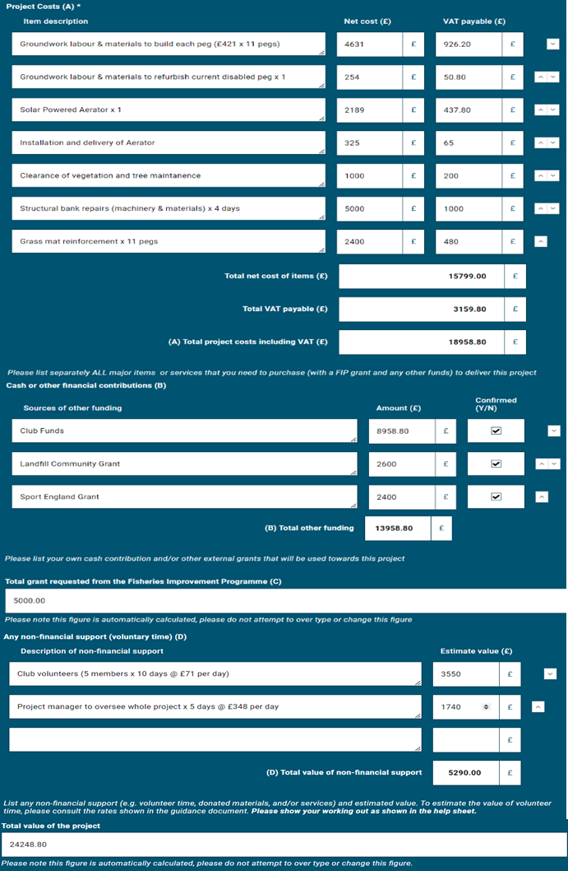
Points to remember
- Ensure that you have uploaded all the documentation if requested
- The judges can only score the information you provide in your application form
- You must click submit in order for your application to be considered

