INSERT NAME OF CLUB OR ORGANISATION
Responding and Reporting a Safeguarding Concern - Process and Procedure
We want everyone to feel safe and valued when they are fishing, so safeguarding of our members while they are involved with club activities is very important to us. It’s vital that any concerns about the safety of junior or vulnerable adult members are reported to the club through our Welfare Officer to ensure that steps are taken to solve any issues. So, what do you do if you witness an incident that involves bullying, abuse, violence or anything that you find concerning? Or if you are approached by a young person or an adult at risk who confides in you about alleged abuse?
In either instance, doing NOTHING is not an option. It is not your job to investigate the disclosure that has been made or the incident that you have witnessed, but you do have a responsibility to respond and report appropriately. In the event of a young person or adult at risk putting their trust in you, you need to understand how hard it has been for them to tell you and give them confidence that you take it seriously and know what to do next. Concerns raised by a third party also need to be recorded and reported.
Try to:
- Remain calm.
- Listen carefully and don’t interrupt.
- Explain early that you can’t keep the details to yourself and that others are there to help.
- Allow them to continue at their own pace.
- Don’t ask leading questions. Tell me, Explain, Demonstrate. (TED)
- Reassure them they are not to blame, and they have done nothing wrong.
- Try to protect evidence, photos of injuries, clothing, etc. and take written notes. Make sure you record date, time and as much detail as you can. Keep it locked away.
- Contact the Welfare Officer (details below) at the first opportunity who will record the details in writing on an Angling Trust incident reporting form and share it with the Angling Trust’s Lead Safeguarding Officer.
Do Not:
- Panic, show alarm or shock.
- Ask questions that lead. Just questions for clarification.
- Speculate, make assumptions or judgements.
- Make promises or keep secrets.
- Make comments about the alleged abuser.
- Share it with other people other than officers that can know.
- Delay in reporting it.
- Keep it to yourself.
If you are unable to contact the welfare officer, then contact the Angling Trust Safeguarding lead (email addresses below). If you feel that the person is in immediate danger or in need of medical treatment dial 999.
Recognise Respond Record Report

Process for Reporting Concerns
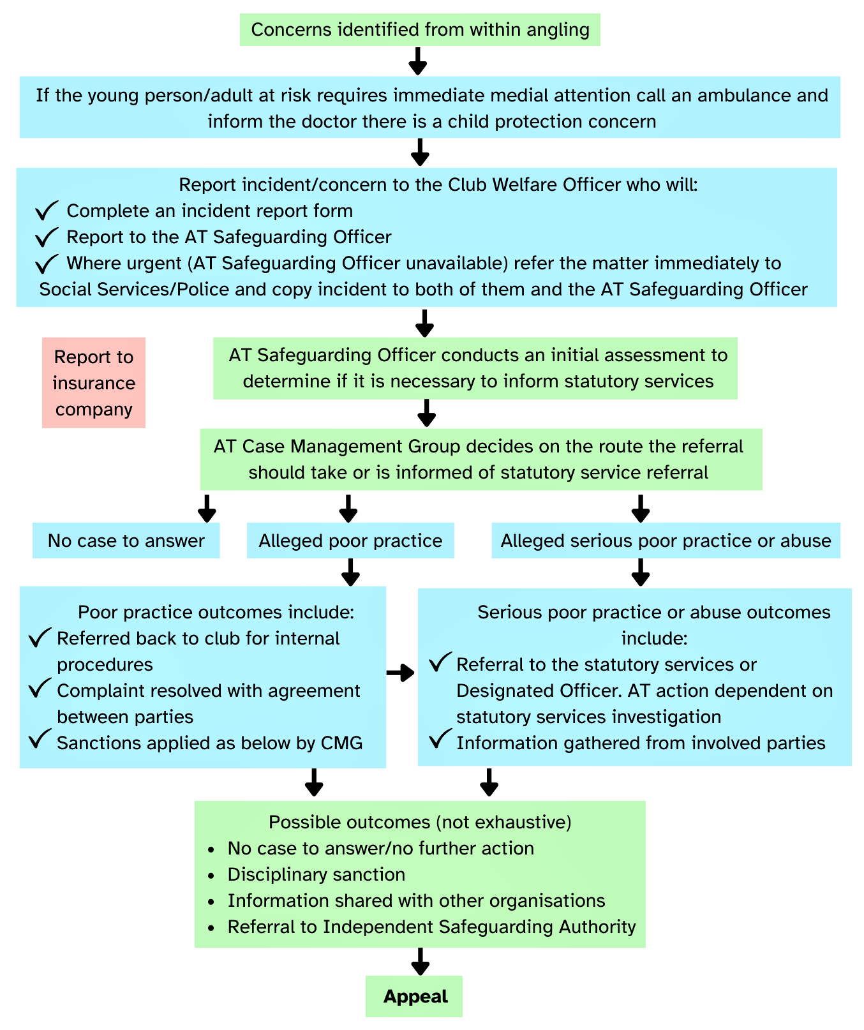

Useful Contacts:
Welfare Officer:
INSERT NAME
INSERT EMAIL
INSERT TELEPHONE NUMBER
Angling Trust Safeguarding Officers:
Lead Safeguarding Officer: Richard.hadley@anglingtrust.net
Deputy Safeguarding Officer: Darren.birch@anglingtrust.net
Competitions Officer: kelly.latimer@anglingtrust.net

