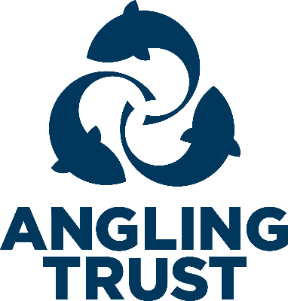

Fishery Visit Checklist
Blue sections are required
Contents
Section One 1
Section Two 2
Section Three 2
Advice 3
Contacts 3

Section One
Form Completed By:
(First Name, Last Name)
Date of Visit:
(DD, MM, YYYY)
Name of angling club, organisation or fishery group that own the fishery:
Name of Contact at Fishery:
(First Name, Last Name)
Position in organisation
Contact Number for Fishery:
Contact Postal Address for Fishery:
Street Address
Address Line 2
Town/City
County
Postcode
Country
Region:
GPS Location of Fishery or What 3 Words:
Latitude and Longitude. Type address into https://www.whatsmygps.com/ OR https://what3words.com/ if you are unsure

Section Two
Are they an Angling Trust Fishery or Club Member? | ☐ Yes  ☐ No
If yes, what is their membership number
Fishery Type? | ☐ Stillwater  ☐ River  ☐ Canal  ☐ Other
Local Environmental Agency Officer:
(First Name, Last Name)

Section Three
This checklist will only be used for the purposes of monitoring what information has been shared with the fishery/club.
Do you consent to be contacted about club/fishery membership of the Angling Trust and/or Fish Legal and the benefits we offer?  If yes, forward on | ☐ Yes  ☐ No
Do you consent for the following information to be shared with the Environment Agency?  If yes, forward on | ☐ Yes  ☐ No

Advice
1 | Predation and ecosystem balance – Does the contact state they have a problem with Otters, Mink, Seals or any species imbalance and do they require further advice?  If yes, forward to FMA’s | ☐ Yes  ☐ No
2 | Invasive Non-native species – Does the contact state there is an invasive species problem (plants, invertebrates, crustaceans) and do they require further advice/assistance/signage?  If yes, forward to EO’s | ☐ Yes  ☐ No
3 | Does the contact state there is a litter problem, and do they require further advice/assistance/signage?  If yes, forward to EO’s | ☐ Yes  ☐ No
4 | Fish health and disease – Does the contact state they have any current/historical issues around fish health and disease and do they require further advice/assistance?  If yes, forward on | ☐ Yes  ☐ No
5 | Water Quality – Does the contact raise any specific water quality issues and does the water suffer from water quality issues which requires further advice?  If yes, forward on | ☐ Yes  ☐ No
6 | Participation – Is the contact interested in running a participation event, do they require any training, and/or additional advice?  If yes, forward on | ☐ Yes  ☐ No
7 | Enforcement – Does the contact experience any illegal commercial fishing practices in the area and does the contact require advice/training, including that of the building bridges team, IFCA or MMO escalation details?  If yes, forward on | ☐ Yes  ☐ No
8 | Funding – Is the contact aware of funding opportunities (AIF/FIP etc) and do they need any further advice/support?  If yes, forward on | ☐ Yes  ☐ No
9 | Access – Are there any known access restrictions or challenges that the contact is aware of and do they need any further advice/support? | ☐ Yes  ☐ No
 | How satisfied are you with our advice today | ☐ Very Satisfied  ☐ Satisfied  ☐ Not Satisfied

Contacts
FMAs (Fishery Management Advisors) – Jake Davoile (South), Richard Bamforth (North)
EOs (Environment Officers) - Ian Doyle (North), Drew Chadwick (South)
Membership contact – john.cheyne@anglingtrust.net
Environment Agency Fisheries Officer – See spreadsheet of contacts
Enforcement – Regional Enforcement Support Manager
Building Bridges – Janusz.kansik@anglingtrust.net
Angling Improvement Fund – aifadmin@anglingtrust.net
Fisheries Improvement Programme – Local EA Fisheries officer
Participation Officer – Relevant Regional contact

For staff contact details please see ‘Staff, Directors and Key Volunteers Directory’ in SharePoint.

