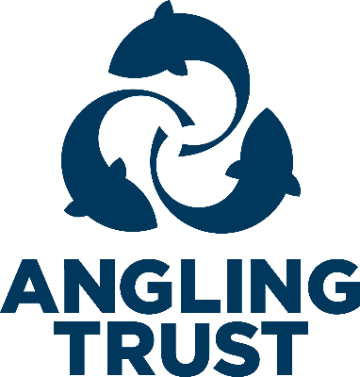

Fishery Visit Checklist
Blue sections are required
Contents
Section One 1
Section Two 2
Section Three 2
Advice 3
Contacts 3

We are collecting this data to ensure that we can provide you with as comprehensive a service as possible by linking you to all the services on offer from the Angling Trust and to be able to sign post you to other organisations that may be able to help you.

Section One
Form Completed By:
(First Name, Last Name)
Date of Visit:
(DD, MM, YYYY)
Name of angling club, organisation or fishery group that own the fishery:
Name of Contact at Fishery:
(First Name, Last Name)
Position in organisation
Contact Number for Fishery:
Contact Email Address
Region:
GPS Location of Fishery or What 3 Words:
Latitude and Longitude. Type address into https://www.whatsmygps.com/ OR https://what3words.com/ if you are unsure

Section Two
Are they an Angling Trust Fishery or Club Member? | ☐ Yes  ☐ No  ☐ To follow
If yes, what is their membership number
Fishery Type? | ☐ Stillwater  ☐ River  ☐ Canal  ☐ Other
Local Environmental Agency Officer:
(First Name, Last Name)

Section Three
Do you consent to be contacted about club/fishery membership of the Angling Trust and/or Fish Legal and the benefits we offer?  If yes, forward on | ☐ Yes  ☐ No
Do you consent for the following information to be shared with the Environment Agency?  If yes, forward on | ☐ Yes  ☐ No

Advice
1 | Predation and ecosystem balance – Does the contact state they have a problem with Otters, Mink, Seals, Fish Eating or any species imbalance and do they require further advice?  If yes, forward to FMA’s | ☐ Yes  ☐ No
2 | Invasive Non-native species – Does the contact state there is an invasive species problem (plants, invertebrates, crustaceans) and do they require further advice/assistance/signage?  If yes, forward to FSO’s | ☐ Yes  ☐ No
2b | Does the contact state there is a litter problem, and do they require further advice/assistance/signage?  If yes, forward to FSO’s | ☐ Yes  ☐ No
3 | Fish health and disease – Does the contact state they have any current/historical issues around fish health and disease and do they require further advice/assistance?  If yes, forward to EA | ☐ Yes  ☐ No
4 | Water Quality – Does the contact raise any specific water quality issues and does the water suffer from water quality issues which requires further advice?  If yes, forward to FSO’s | ☐ Yes  ☐ No
5 | Participation – Is the contact interested in running a participation event, do they require any training, and/or additional advice?  If yes, forward to James Roche | ☐ Yes  ☐ No
6 | Enforcement – Does the contact experience any illegal commercial fishing practices in the area and does the contact require advice/training, including that of the building bridges team, IFCA or MMO escalation details?  If yes, forward to Nino Brancato | ☐ Yes  ☐ No
7 | Funding – Is the contact aware of funding opportunities (AIF/FIP etc) and do they need any further advice/support?  If yes, forward to AIF Admin team | ☐ Yes  ☐ No
 | How satisfied are you with our advice today | ☐ Very Satisfied  ☐ Satisfied  ☐ Not Satisfied

Contacts
For staff contact details please see ‘Staff, Directors and Key Volunteers Directory’ in SharePoint.

