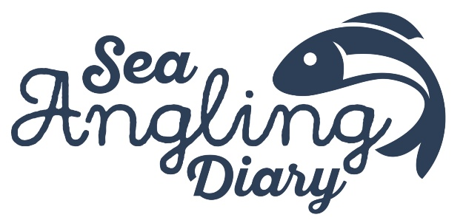
Sea Angling Diary Steering Group Expression of Interest (EOI) Form
Thank you for your interest in joining the Sea Angling Diary (SAD) Steering Group.
The Steering Group is an advisory body established to support the long-term development, credibility and uptake of the Sea Angling Diary, and to strengthen trust, transparency and co-design between anglers, science and management.
Please complete the short form below and return it as instructed by the Angling Trust.
1. Your details
Full name:
Email address:
Telephone (optional):
Organisation / affiliation (if applicable):
Your current role or position (if applicable):
2. Sector you would represent
Please select the sector that best reflects your main perspective:
☐ Recreational sea angler (shore-based)
☐ Recreational sea angler (boat-based / private boat)
☐ Charter skipper / charter sector representative
☐ Tackle trade (manufacturer, distributor or retailer)
☐ Research / academic
☐ Non-governmental organisation (NGO)
☐ Other (please specify): _______________________________
3. Location
Please indicate the main area(s) you fish, work or operate in (England and/or Wales):

4. Relevant experience and perspective
Briefly describe the experience, knowledge or perspective you would bring to the Sea Angling Diary Steering Group.
(For example: type of angling you do, involvement in charter fishing, data collection, fisheries projects, community work, research, or sector representation.)
5. Statement of interest
In a short statement (maximum 250 words), please explain why you would like to be a member of the Sea Angling Diary Steering Group and what you hope to contribute.
6. Ability to engage constructively
The Steering Group is intended to be a collaborative and constructive advisory forum.
Please briefly confirm that you are willing and able to:
• engage respectfully with a wide range of views and sectors
• contribute to group discussions in a constructive way
• act in the wider interests of the Sea Angling Diary rather than as a delegate or lobbyist
Confirmation:
7. Conflicts of interest
Please declare any actual or potential conflicts of interest that could be relevant to your participation in the Steering Group (for example, commercial interests, consultancy roles, or formal advisory positions).
If none, please write “None”.
8. Time commitment
The Steering Group is expected to meet 2–3 times per year, primarily online.
Please confirm that you are able to commit to this level of involvement.
☐ Yes, I am able to commit to attending meetings and contributing between meetings where required.
9. Data protection and use of information
The information provided in this form will be used by the Angling Trust, Cefas and Substance solely for the purpose of selecting members for the Sea Angling Diary Steering Group.
Personal data will be handled in accordance with applicable data protection legislation.
10. Declaration
I confirm that the information provided in this form is accurate to the best of my knowledge.
Name:
Signature:
Date:
Once complete, please submit this form to sea@anglingtrust.net.

